Goals:
Can mount securely hold the camera
How far does sami keep going after a stop is called
Find proper stopping distance

Steps:
Mount camera
Duct tape if necessary to secure camera
- Good or need to change cad?
Plug into computer
Move huskey over to open area
Place an object in view (centre of screen only for now) - use a mat for a solid flat surface that has some give in case of collision
Measure out 0.5 m in front of the object
Slowly move sami forwards and see if it detects the object
Measure how far past the 0.5 line it is when it comes to a complete stop
Repeat with faster speeds
Echo the terminal prints and view them after to see what happened or echo cmd_vel

Results:
Mount had to be moved to the very front of the robot or redesign mount to be higher. The cover was showing up in the camera view and causing it to think an object was less than 0.5 m away. Temporary setup shown below.

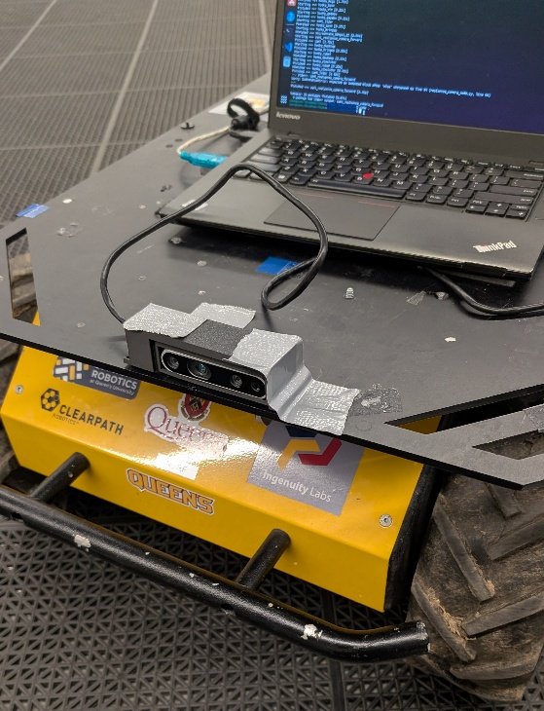
Tested with the current program but it allows keyboard commands to slip through in the 0.5 delay because the processing speed of laptop for the model is too slow while it gets the next one more than 0.5 (the timeout) passes so keyboard commands slip through and allow the robot to move when it shouldn't. This is a safety hazard. We must make it lock like the estop until it gets an ok command. Change instead of sending speeds send true or false bool. We were able to perform tests now.
Raw data is in the excel file.

